**Step 1:**

Create a VM and add the following details which we need .

After creating Click on the VM we have launched.

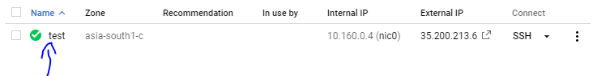

**Step 2:**

Then, Click on disk which disk we want to extend.

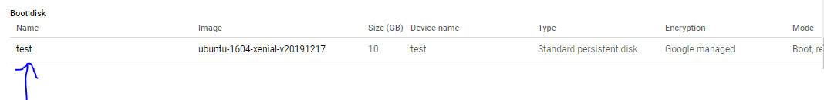

After clicking the Disk, it will navigate to disk section.

**Step 3:**

Click Edit to extend the disk and extend the disk what we need.

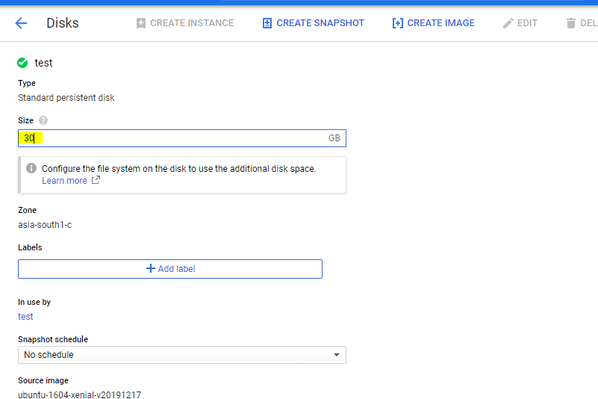

After entering the Disk size. Click Save.

**Step 4:**

Then to Configure in Server. Click on SSH.

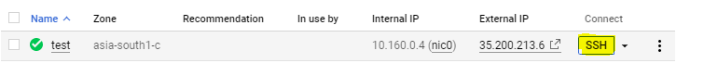

Type df -h to check the Mount and then type the following commands to make changes in server.

1. **fdisk -l**

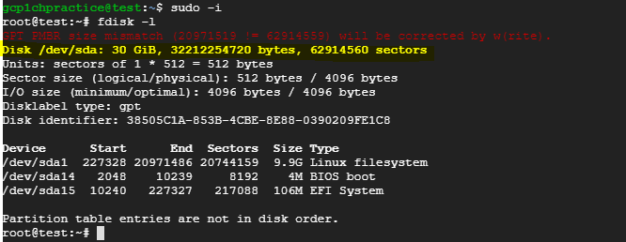

It will show the size of the disk which we have extended.

Then Type the next command

1. **growpart /dev/sda 1**



It will show the above output.

Then type the resize command

1. **resize2fs /dev/sda1**

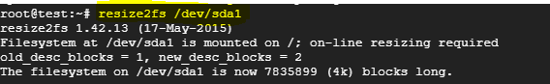

After executing the above three commands.

Check whether the disk is extended or not.

